**7.5 Test Cases Conclusion**

This section contains summary of performance evaluation (sec. **??**), adversary behavior impact on our approach (sec. **??**), *calculation load* in (sec. **??**).

# 7.5.1 Performance Evaluation

Performance of test cases was evaluated according to criteria given by (sec. **??**). The performance for *test cases* from test plan (tab. **??**) has been summarized in (tab. **??**).

|  |  |  |  |  |  |  |  |  |
| --- | --- | --- | --- | --- | --- | --- | --- | --- |
| Scenario name | Safety Margin | | | Tr | trajectory tracking | |  | Pass  /  Fail |
| Distance | | Breach | Waypoint  Reach | Reference  Deviation | | Acceptable  Deviation |
| min | max |
| Building avoidance  (sim. **??**) | 0.69 m UAS 1 | 24.98 m  UAS 1 | No  (**??**) | Yes/UAS 1/(**??**) | WP1 :  WP2 :  WP3 :  WP4 : | 107*.*05*m*  86*.*20*m*  28*.*70*m*  32*.*84*m* | Yes (**??**) | Pass |
| Slalom (sim. **??**) | 0.09 m UAS 1 | 3.74 m UAS 1 | No  (**??**) | Yes/UAS 1/(**??**) | WP1: | 20*.*06*m* | Yes (**??**) | Pass |
| Maze (sim **??**) | 0.01 m UAS 1 | 2.95 m UAS 1 | No  (**??**) | Yes/UAS 1/(**??**) | WP1 : | 28*.*06*m* | Yes (**??**) | Pass |
| Storm (sim. **??**) | 0.04 m UAS 1 | 34.99 m  UAS 1 | No  (**??**) | Yes/UAS 1/(**??**) | WP1: | 15*.*76*m* | Yes (**??**) | Pass |
| Emergency  Converging  (sim. **??**) | 1.67 m  UAS 1-2 | 27.08 m  UAS 1-1 | No  (**??**) | Yes/UAS 1/(**??**)  Yes/UAS 2/(**??**) | WP1 : 3*.*25*m*  WP1 : 0*.*00*m* | | Yes (**??**) | Pass |
| Emergency  Head On  (sim. **??**) | 0.38 m  UAS 1-2 | 38.00 m  UAS 1-2 | No  (**??**) | Yes/UAS 1/(**??**)  Yes/UAS 2/(**??**) | WP1 : 3*.*25*m*  WP1 : 0*.*00*m* | | Yes (**??**) | Pass |
| Emergency  Multiple  (sim. **??**) | 0.20 m  UAS 2-4 | 45.46 m  UAS 3-4 | No  (**??**) | Yes/UAS 1/(**??**)  Yes/UAS 2/(**??**)  Yes/UAS 3/(**??**)  Yes/UAS 4/(**??**) | WP1 : 4*.*84*m*   |  |  | | --- | --- | | WP1 : | 1*.*83*m* | | WP1 : | 3*.*45*m* |   WP1 : 2*.*05*m* | | Yes (**??**) | Pass |
| Rule-based  Converging  (sim. **??**) | 1.22 m  UAS 1-2 | 20.28 m  UAS 1-2 | No  (**??**) | Yes/UAS 1/(**??**)  Yes/UAS 2/(**??**) | WP1 : 10*.*22*m*  WP1 : 0*.*00*m* | | Yes (**??**) | Pass |
| Rule-based  Head On  (sim. **??**) | 0.21 m  UAS 1-2 | 36.33 m  UAS 1-2 | No  (**??**) | Yes/UAS 1/(**??**)  Yes/UAS 2/(**??**) | WP1 : 5*.*40*m*  WP1 : 5*.*40*m* | | Yes (**??**) | Pass |
| Rule-based  Multiple  (sim. **??**) | 0.54 m  UAS 2-3 | 32.24 m  UAS 1-2 | No  (**??**) | Yes/UAS 1/(**??**)  Yes/UAS 2/(**??**)  Yes/UAS 3/(**??**)  Yes/UAS 4/(**??**) | WP1 : 11*.*40*m*   |  |  | | --- | --- | | WP1 : | 11*.*40*m* | | WP1 : | 11*.*40*m* |   WP1 : 11*.*40*m* | | Yes (**??**) | Pass |
| Rule-based  Overtake  (sim. **??**) | 0.80 m  UAS 1-2 | 48.85 m  UAS 1-2 | No  (**??**) | Yes/UAS 1/(**??**) | WP1 : 24*.*00*m*  WP2 : 0*.*00*m*  WP3 : 4*.*00*m*  WP4 : 5*.*00*m* | | Yes (**??**) | Pass |
|  |  |  |  | Yes/UAS 2/(**??**) | WP1 : 0*.*00*m* | |  |  |

Table 7.1: Test cases *performance evaluation*.

**Highlights:** Each *scenario* contains the reference to notable simulation moments and results. The scenarios were grouped according to the *Operational Space* category, and each category is separated by strike line.

*Non-cooperative test cases for the Rural/Urban environment:*

1. *Static obstacle avoidance* (Building/Slalom/Maze) - the buildings were correctly avoided without security breach; navigation algorithm was sufficient for given scenarios and obstacle density.
2. *Weather avoidance* (Storm) - the moving *storm* have been avoided in both *soft constraint* and *hard constraint* state. The assumption of *early detection/notification* is key in successful weather avoidance.

*Non-cooperative test cases for Intruder Avoidance* - the key assumptions are early intruder detection in *Avoidance Grid* and *non-adversarial* behavior. Each UAS was running own instance of *Navigation loop* (fig. **??**). The summary of test cases is going like follow:

1. *Emergency converging* - both UAS identified correct roles according to rules of the air. The UAS 2 kept *right of the way*.
2. *Emergency head on* - both UAS identified correct roles according to rules of the air, both of them uses full separation with *Combined Reach Set Approximation* (sec.

**??**).

1. *Emergency mixed* - all four UAS enters into emergency avoidance mode intermediately after intruders detection. The *non-cooperative* consensus of separation is reached (fig. **??**)

*Cooperative test cases with UTM supervision* are working according to *UTM architecture* (fig. **??**), where the *UTM* is considered as main authority. The key assumptions are UTM Resolution fulfillment and *non-adversary behavior*. Each UAS was running own instance of *Navigation loop* (fig. **??**) with enabled *Rule Engine* (sec. **??**). The summary of test cases is going like follow:

1. *Rule-based converging* - correct handling of *converging maneuver* (fig. **??**), proper rule invocation (rule **??**) on UAS side.
2. *Rule-based head on* - correct handling of *head on maneuver* (fig. **??**), proper rule invocation (rule **??**) on UAS side.
3. *Rule-based multiple* - proper *Collision case Merge* (tab. **??**) with new collision point (eq. **??**) and *safety margin calculation* (eq. **??**).
4. *Rule-based overtake* - correct handling of *overtaking maneuver* (fig. **??**), proper rule invocation (rule **??**). Divergence/Convergence (eq. **??**,**??**) for multiple waypoints calculation works for various speed difference (fig. **??**).

# 7.5.2 Adversary Behaviour Impact

The *abuse* of UAS for *ill intentions* realization is expected. The *UAS* is cheap, disposable and does not have ethic boundaries.

One of the *assumptions* was that there are only intruders who do not actively look to harm our *UAS*. Breaking this assumption can be lethal for our system and also for other systems.

Let us take *Rule-based Head on* test case (sec. **??**), changing only following aspects:

1. *UAS 2 position spoofing* - the adversarial vehicle is *faking its position* according to expected behavior.
2. *UAS 2 Navigation goal* - set as *UAS 1 position* from intercepted *position notifications* (tab. **??**).

**Simulation:** The *simulation* (fig. **??**) have been run with defined condition. UAS

2 (magenta) has been chosen as the *adversary*. UTM sees the expected trajectory of UAS 2 (grey plane/trajectory) based on spoofed *position notifications*. The *navigation/avoidance grid* range (black dashed line boundary) is shown. The notable moment of the simulation are:

1. *Deviation detection (UAS*2 ↔ *UTM)* (fig. **??**) - the *collision case* (tab. **??**) is active and *enforced* by UTM. The *adversary* UAS 2 (magenta) starts deviating from expected trajectory (grey). UAS 1 (blue) does not register any foreign object in *avoidance grid range* (black dashed line).
2. *Adversary attacking (UAS*2 → *UAS*1*)* (fig. **??**) - the adversary UAS 2 (magenta) starts actively pursuing UAS 1 (blue) by changing the original heading. This can be considered as the beginning of *active pursuit*. UAS 1 (blue) does not detect any foreign object in *avoidance grid* (black dashed line boundary). *UTM* is receiving expected UAS position (grey plane/line).
3. *Emergency avoidance* (*UAS*1 → *UAS*2) (fig. **??**) following happens:
   1. *Adversary UAS 2* (magenta) is spotted by *UAS 1*(blue), it entered into UAS 1 avoidance grid (black dashed line boundary).
   2. *UAS 1* (blue) enters into *Emergency Avoidance Mode* because there is a *foreign object* *avoidance grid*.
   3. *UTM* notices a warning to *UAS 1* (blue) because it entered into *Emergency Avoidance Mode*. UTM is not aware of any breach, because of expected UAS 2 position (grey plane/line)
   4. *Adversary UAS 2* (magenta) has UAS 1 (blue) locked in *navigation grid* as the goal (which guarantees optimal path).
4. *Blind spot (* *UAS*1*)* (fig. **??**) following happens:
   1. *UAS 1* (blue) returns to *Navigation Mode* because there is no *foreign object* in *avoidance grid* (black dashed line boundary).
   2. *UTM* receives the mode change, and it starts enforcing *resolutions* for *collision case*, Adversary *UAS 2* is considered clear due to *expected position* (grey plane/line) compliance with the resolution.
   3. *Adversary UAS 2* (magenta) is on UAS 1 blind spot. The target UAS 1 (blue) is locked in the UAS 2 navigation grid (black dashed line boundary).
5. *Collision detail (UAS*1 ↔ *UAS*2*)*(fig. **??**) - Target *UAS 1* (blue) is hit by *Adversary UAS 2* (magenta) on left wing tip. Both UAS are going down. UTM will detect sudden loss of both UAS systems.

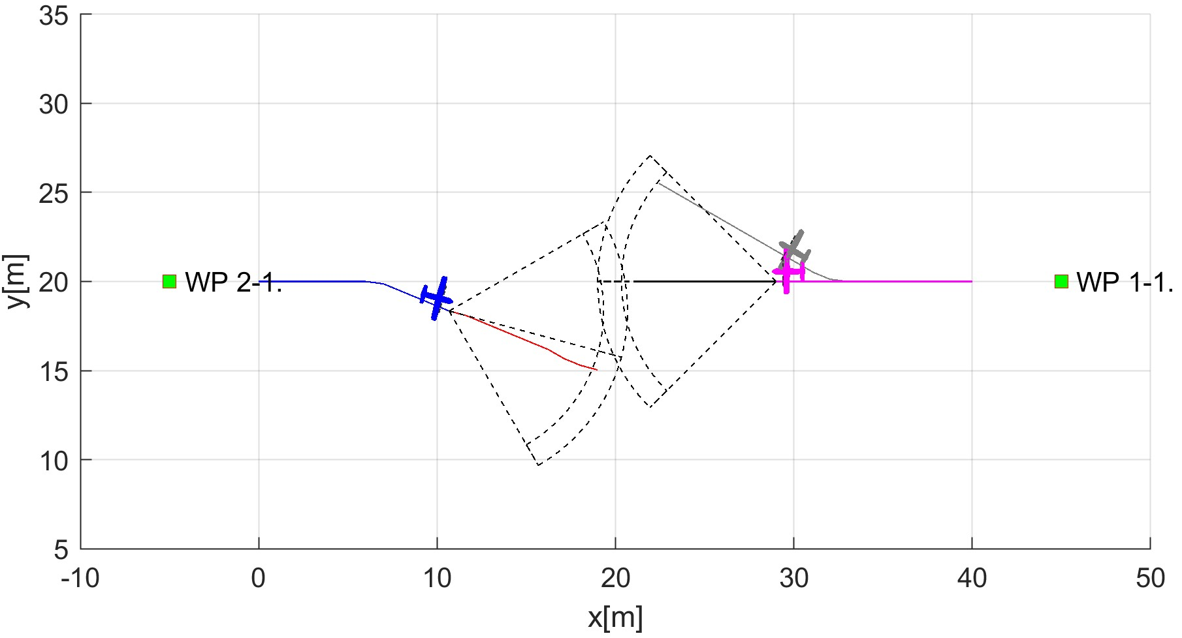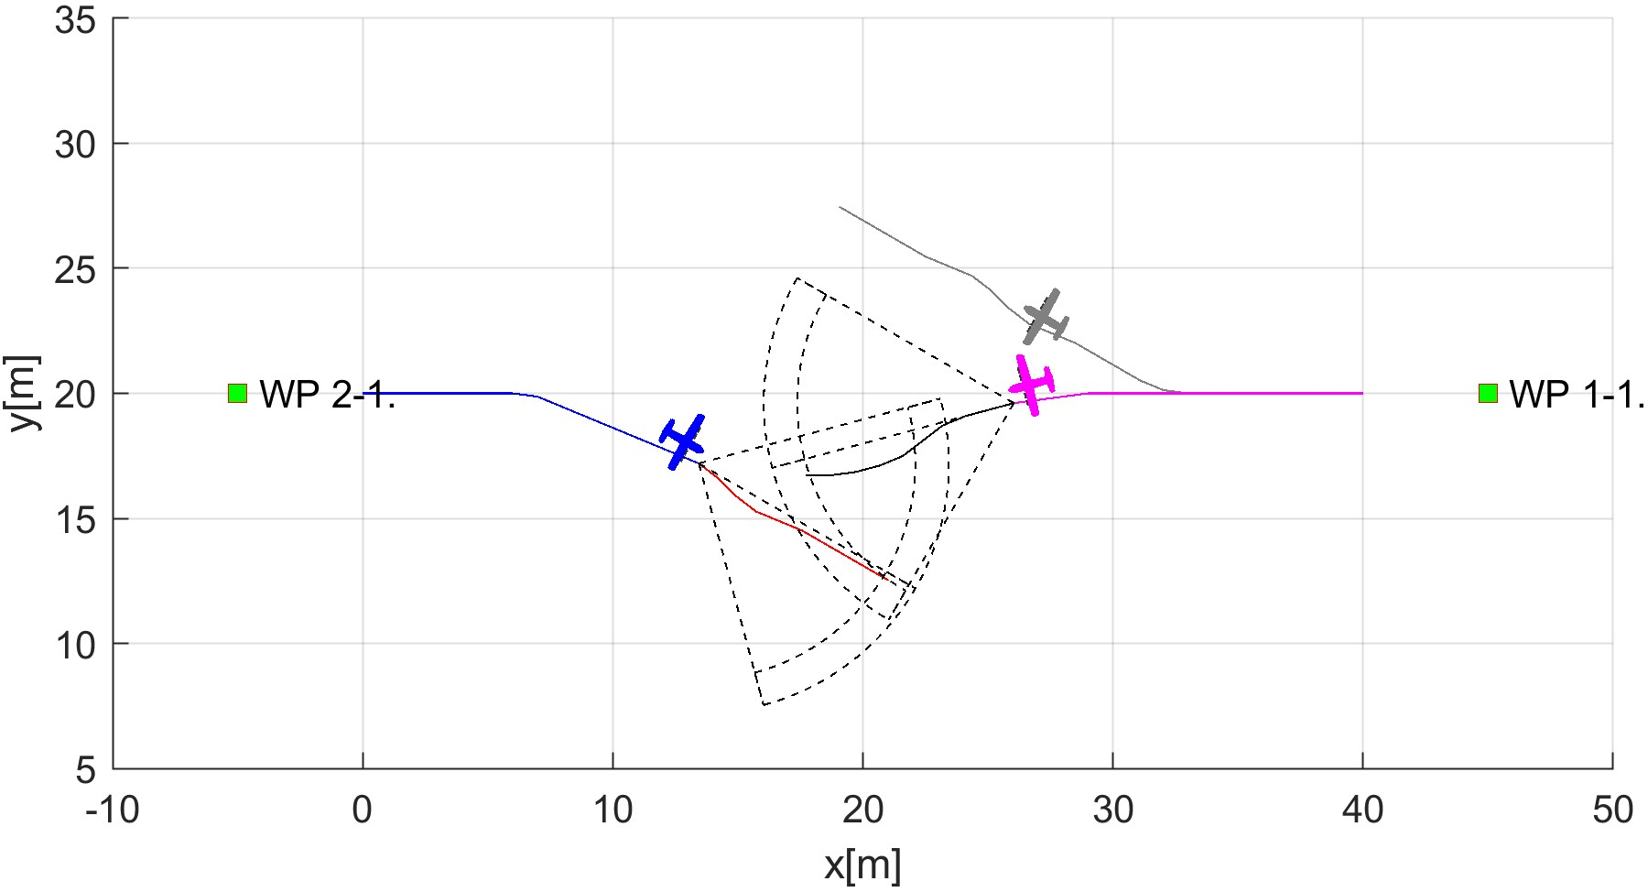

* 1. Deviation detection (UAS 2). (b) Adversary attacking (UAS 2).

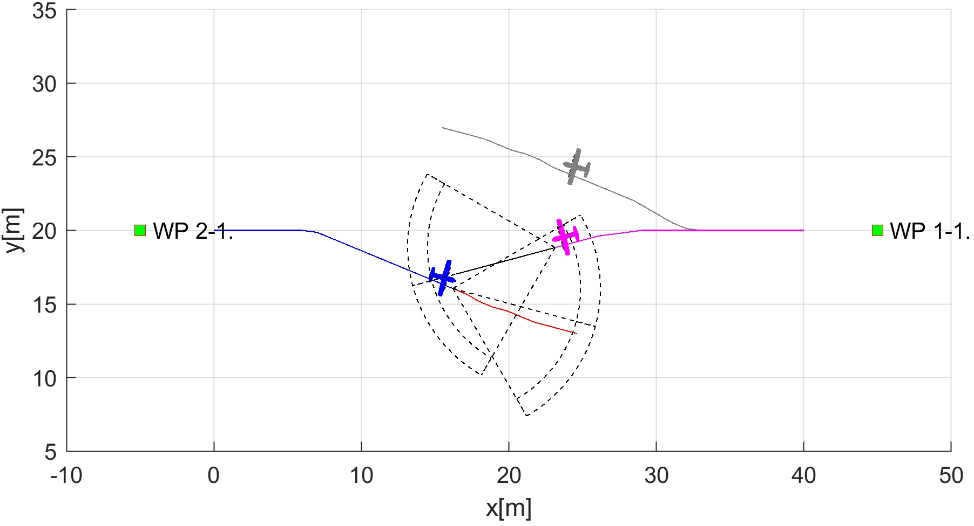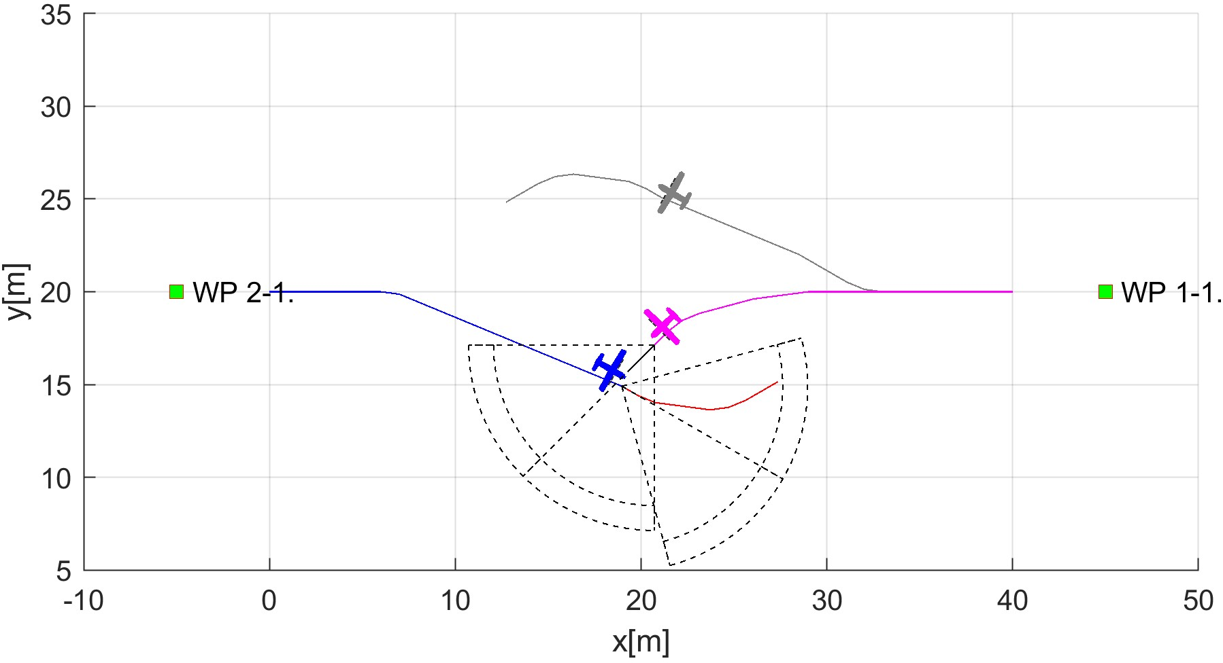

(c) Emergency avoidance (UAS 1). (d) Blind spot (UAS 1).

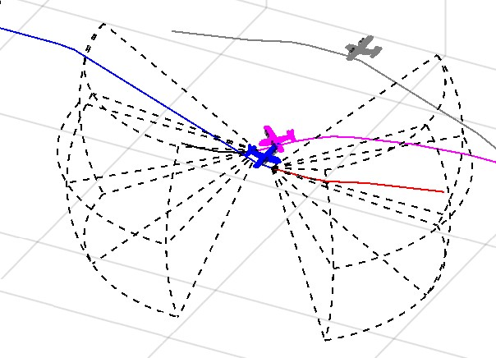

(e) Collision detail.

Figure 7.1: Adversarial behaviour of *UAS 2* (magenta) to compliant *UAS 1* (blue)

**Performance Parameters Evaluation:** Performance parameters (y-axis) are tracked over *UTM time* (x-axis). The evolution of *performance* (fig. **??**) is tracking following parameters:

1. *Expected crash distance* (gray line) - defined as (eq . **??**) between UAS 1 (blue)and expected UAS 2 position (grey plane/line) over mission time *t* ∈ [0*,*22].
2. *Crash distance* (blue line) - defined as (eq . **??**) between UAS 1 (blue) and real UAS 2 position (magenta plane/line) over mission time *t* ∈ [0*,*22].
3. *Safety margin* (yellow line) - constant value according to *collision case* (tab. **??**) as the value of *10 m*. The safety margin is considered as *soft constraint*.
4. *Body margin* (red line) - constant value according to (tab. **??**) as value of *1.2 m*. The body margin is considered as *hard constraint*. The breaking of *body* margin means an effective *collision* UAS 1 and UAS 2.

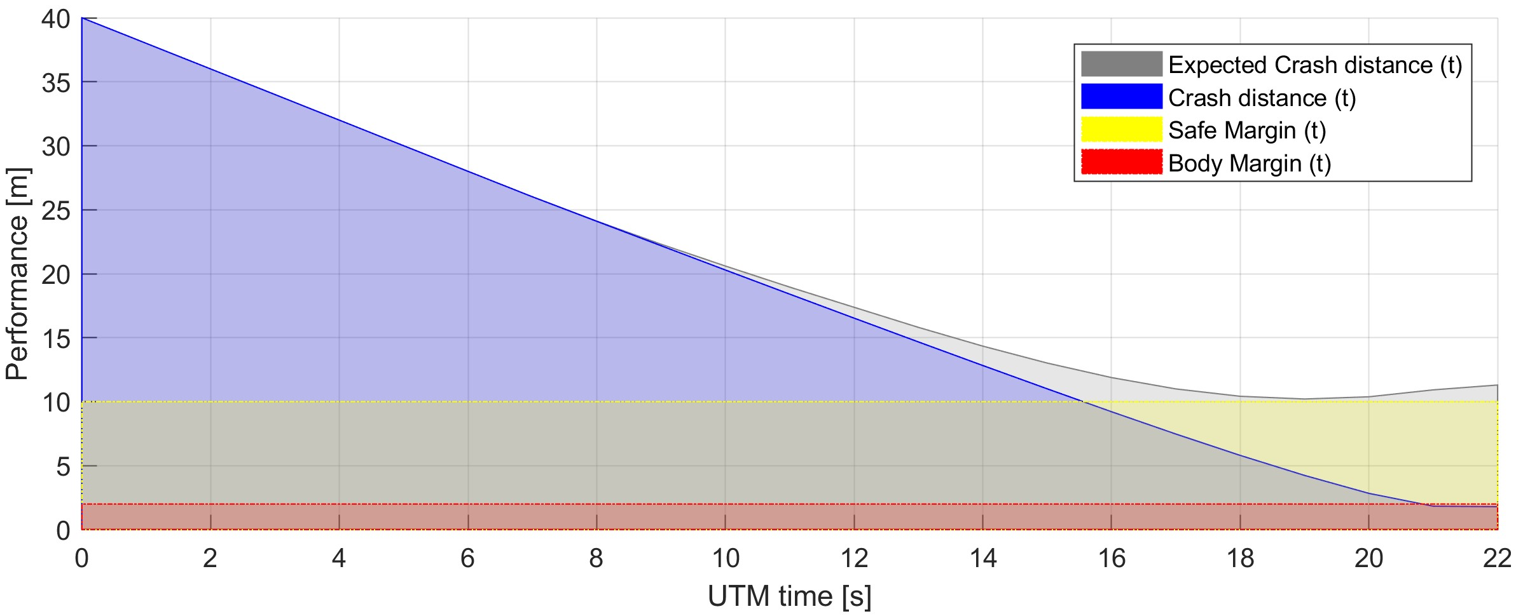

Figure 7.2: Expected/Real Distance to body/safety margin evolution for *adversarial behavior* of UAS 2.

*Safety criteria* for both *body* and *safety margins* in case of *expected behavior* are satisfied (eq. **??**). This means that *UAS 1* fulfilled the *UTM directive* even though it entered *Emergency Avoidance Mode* (fig. **??**).

|  |  |  |
| --- | --- | --- |
| *expectedDistanceToSafetyMargin*(*t*) ≥ 0*,* | ∀*t* ∈ [0*,*22] | (7.1) |
| *expectedDistanceToBodyMargin*(*t*) ≥ 0 | ∀*t* ∈ [0*,*22] |  |

*Safety Margin* is broken at UTM time *15 s*, *body margin* is broken at UTM time *21 s*, the collision happens at UTM time *22 s*. This is summarized in *Distance Condition Breach* (eq. **??**).

|  |  |  |
| --- | --- | --- |
| *distanceToSafetyMargin*(*t*) *<* 0*,* | ∀*t* ∈ [21*,*22] | (7.2) |
| *distanceToBodyMargin*(*t*) *<* 0 | ∀*t* ∈ [15*,*22] |  |

*Note.* An *adversary behavior* needs to be addressed on:

1. *UAS Traffic Management Level* - our UTM implementation failed to detect *deviation* (fig. **??**) and *start of attack* (fig. **??**). UAS 2 (magenta) had clean intention from the beginning and did not change pursuit even when *safety margin* was breached.
2. *Emergency Avoidance Level* - our *navigation loop implementation* does not consider the *ill-intentions*. The UAS 1 (blue) properly switched to *Emergency avoidance mode* (fig. **??**) after detection of UAS2 (magenta). UAS 2 (magenta) then used the blind spot to exploit UAS 1 vulnerability.

# 7.5.3 Computation Footprint

The *computation footprint* is summarized in computation load (tab. **??**). The *computation load* (eq. **??**) was calculated for each *time-frame* in scenarios. There is the summary of *minimal, maximal, average* and *median* values.

The *computational load* never exceed more than 55*.*95% in case of *emergency Head On* (eq. **??**), which means that *every path* was calculated on time.

|  |  |  |  |  |
| --- | --- | --- | --- | --- |
| Scenario | Computation load | | | |
| min. | max. | avg. | med. |
| Building avoidance (fig. **??**) | 2.20% | 27.40% | 12.11% | 13.20% |
| Slalom (fig. **??**) | 12.20% | 30.50% | 21.42% | 21.50% |
| Maze (fig. **??**) | 24.90% | 46.10% | 31.51% | 30.80% |
| Storm (fig. **??**) | 2.60% | 26.90% | 11.57% | 13.90% |
| Emergency Converging (fig. **??**) | 2.75% | 16.50% | 5.84% | 4.95% |
| Emergency Head On (fig. **??**) | 3.90% | 55.95% | 13.19% | 6.90% |
| Emergency Multiple (fig. **??**) | 5.90% | 52.35% | 12.77% | 8.56% |
| Rule-based Converging (fig. **??**) | 3.60% | 13.50% | 7.32% | 5.97% |
| Rule-based Head on (fig. **??**) | 4.65% | 41.60% | 13.64% | 9.30% |
| Rule-based Multiple (fig. **??**) | 4.37% | 23.30% | 11.96% | 10.93% |
| Rule-based Overtake (fig. **??**) | 3.85% | 13.40% | 7.62% | 6.70% |

Table 7.2: *Computation load statistics* for all test cases.

*Following observations can be made:*

1. *Building avoidance*, *Slalom*, and *Maze* scenarios - the computation load is increasing with the *number of static obstacles*. The *average load* for *Emergency avoidance mode* in *clustered environment* is 31*.*51% (Maze).
2. *Storm scenario* - the overall *computation load* is very low due to the *moving constraint implementation* (sec. **??**).
3. *Emergency Converging/Head On/Multiple* scenarios - the *overall computation load* is quite high due to the ineffective *body volume intersection* (sec. **??**) implementation.
4. *Rule-based Converging/Head On/Multiple* scenarios - the *median computational* load is low, because of the linear *rule implementation* (sec. **??**)
5. *Rule-based Overtake* - the *average computation load* is very low because only *divergence/convergence* (rule. **??**) waypoints are calculated and UAS stays in *navigation mode*.